Bouns 3

Zhuoling Chen

chenz6@oregonstate.edu

1.

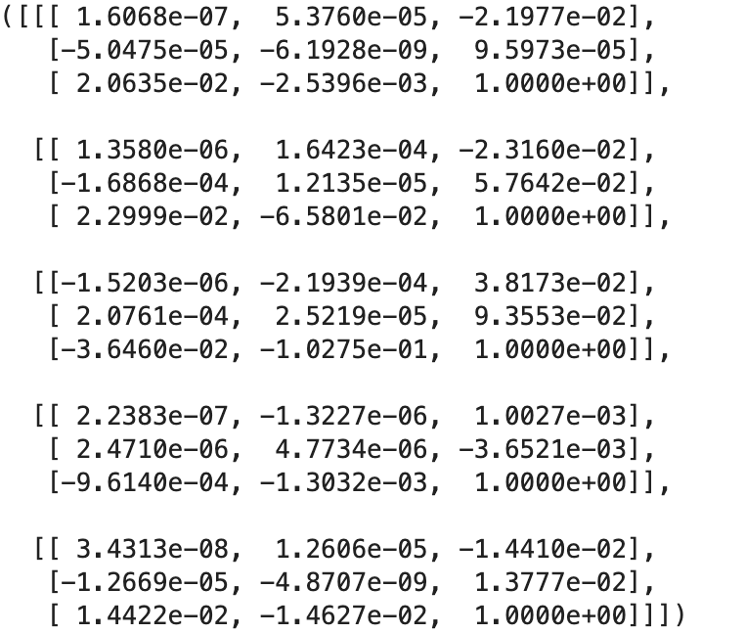

2.

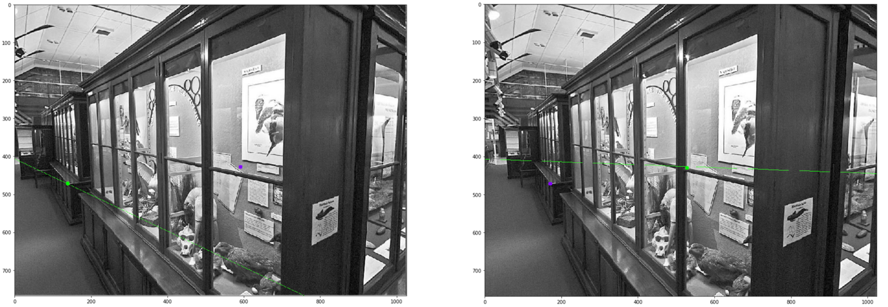

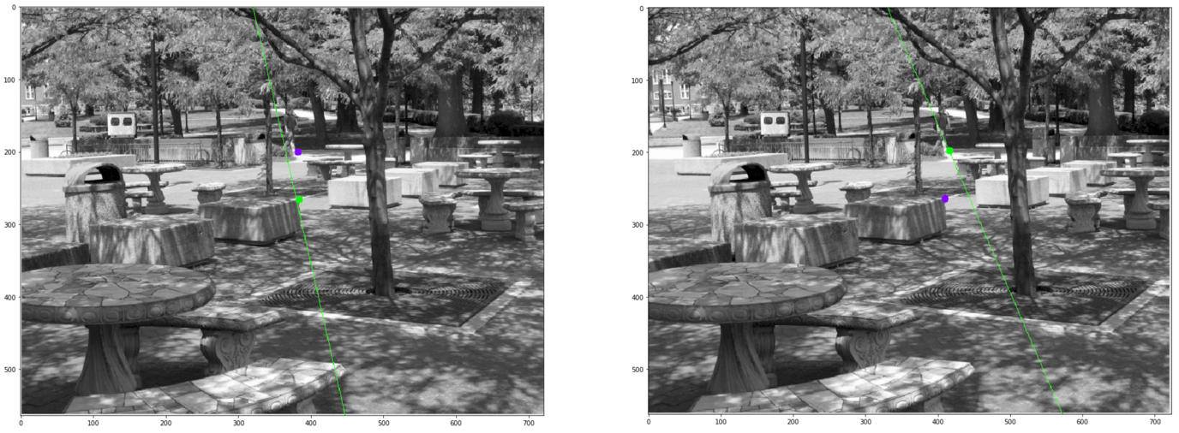

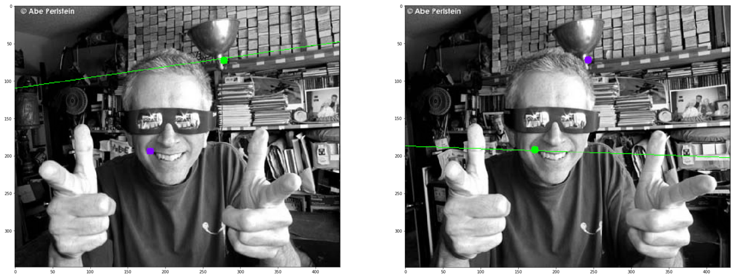

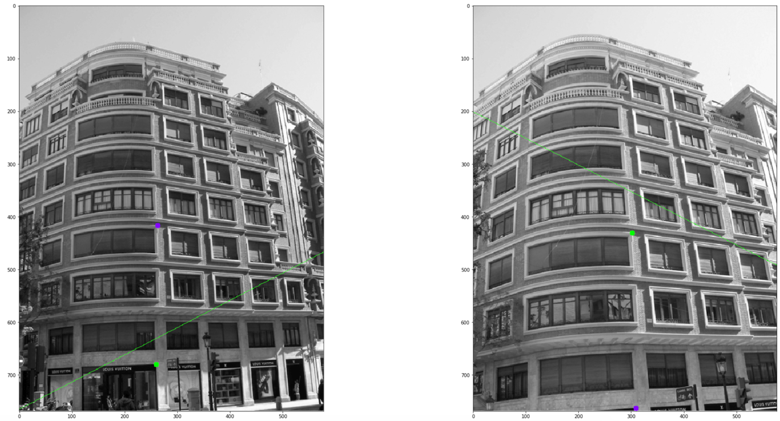

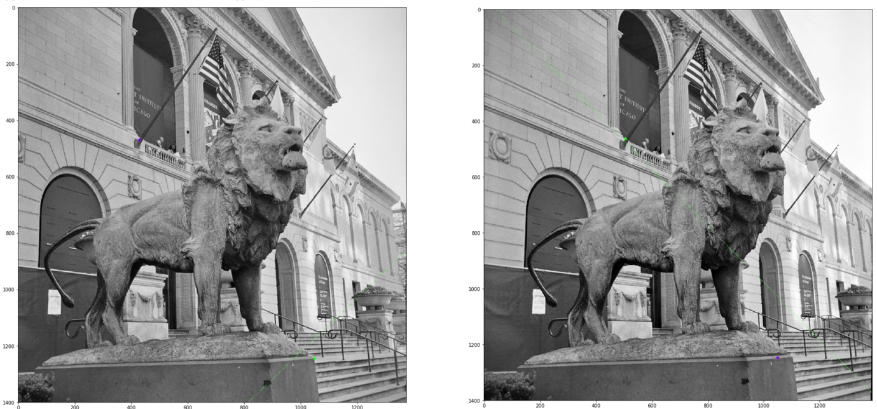

4.

|  |  |  |  |
| --- | --- | --- | --- |
| Img name | Point in Img(select) | Epipolar line F2 | Pass or Not |
| Img11 | [171 472]  From img12 | [[ -0.4293965 0.90311605 -368.4027 ]] | P |
| Img12 | [591 428] in img11 | [[ 3.7858803e-02 -9.9928308e-01 4.0687762e+02]] | P |
| Img21 | [382 200]  From img 22 | [[-9.7568178e-01 2.1919186e-01 3.1283163e+02]] | P |
| Img22 | [410 265]  In img 21 | [[ 0.9193526 -0.3934347 -303.98917 ]] | P |
| Img31 | [180 194] from  img32 | [[ -0.14044887 -0.9900879 109.19385 ]] | P |
| Img32 | [243 72]  In img 31 | [[-3.4315050e-02 9.9941105e-01 -1.8762140e+02]] | P |
| Img41 | [263 417]  From img42 | [[ 4.5752123e-01 8.8919872e-01 -6.8028937e+02]] | P |
| Img42 | [309 763]  In img 41 | [[ 0.4501734 -0.8929412 179.796 ]] | P |
| Img51 | [430 469]  From img 52 | [[-6.9245225e-01 -7.2146368e-01 1.5752849e+03]] | P |
| Img52 | [1050 1247]  In img 51 | [[-0.7136601 0.70049214 28.723513 ]] | P |

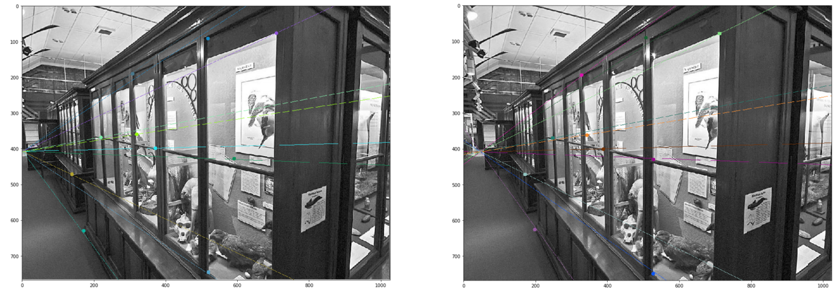

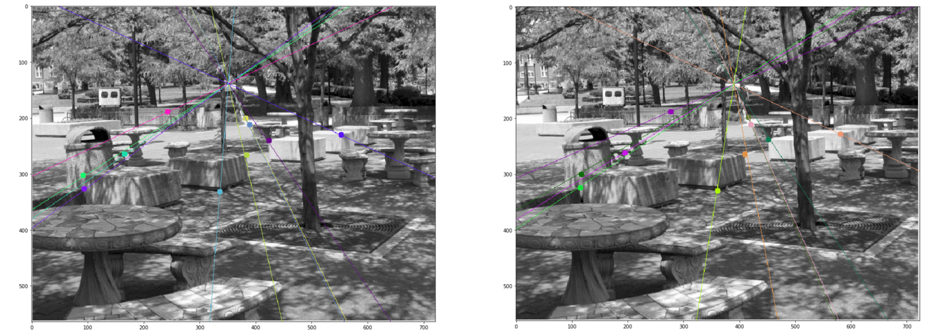

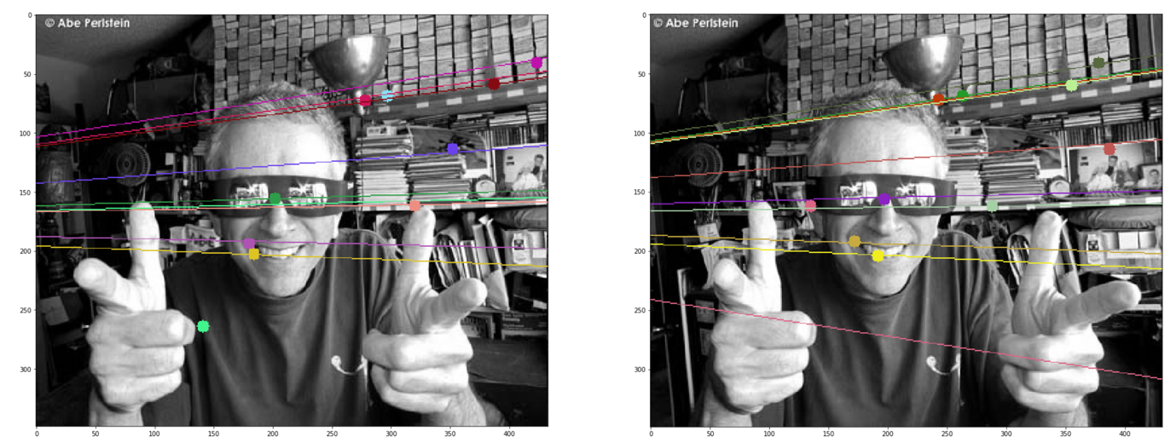

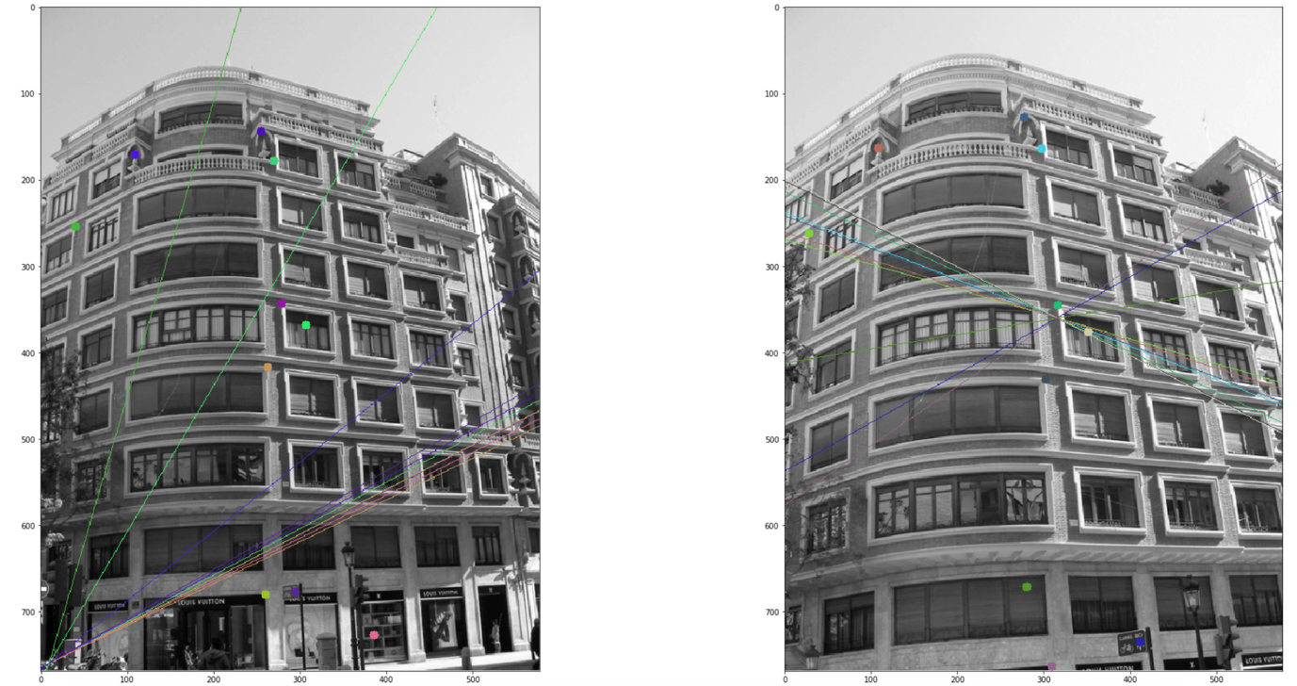

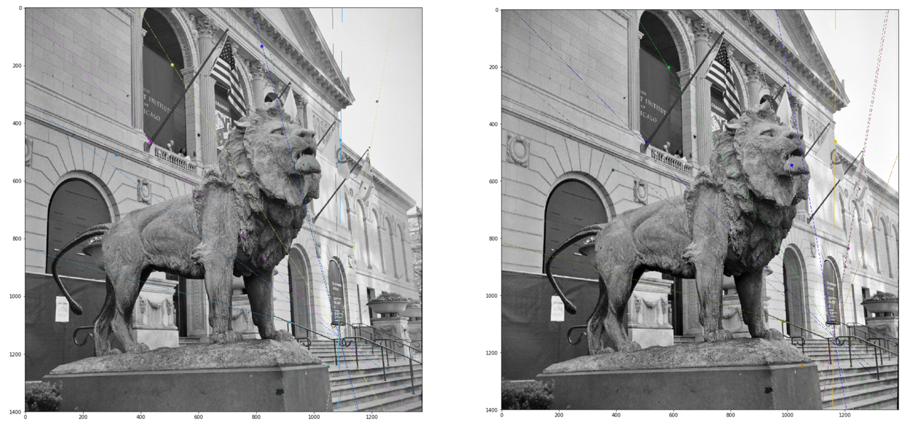

|  |  |  |
| --- | --- | --- |
| Epipoles | Image1 | Image2 |
| 1 | Out of image  1.851259,408.8042 | 47.287094 ,408.96106 |
| 2 | 351.6562 ,138.11125 | 390.35083, 139.49191 |
| 3 | Out of image  -472.15112 , 177.26396 | Out of image  -448.5431 , 172.33107 |
| 4 | Out of image  10.172051, 759.8251 | [315.64365, 360.48328 |
| 5 | 1.0870155e+03, 1.1401531e+03 | 1.1607107e+03 ,1.1415253e+0 |